Pokhara University

Level: Bachelor | Semester – Spring | Year : 2007
Programme: BE |  | Full Marks: 100
Course: Basic Electrical Engineering |  | Time : 3hrs.

Candidates are required to give their answers in their own words as far as practicable.
The figures in the margin indicate full marks.

Attempt all the questions.

 | - Discuss active and passive circuit elements. For the circuit given below calculate the value of V₁ using mesh analysis.  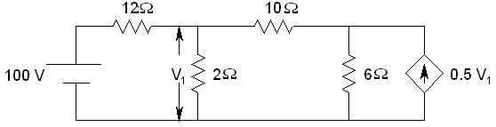  - State maximum power transfer theorem. Find the value of R_{L} for maximum power transfer in the circuit below.  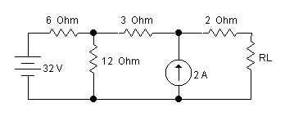 | 8  7
 | - Explain Voltage and current divider rule.  - Calculate the power consumed by 6Ω resistor using Norton’s theorem in the figure given below.  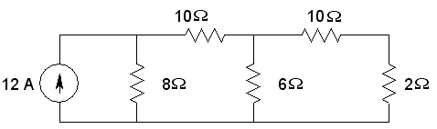 | 7  8
 | - Find the average value, effective value and form factor of the periodic waveform shown in figure.  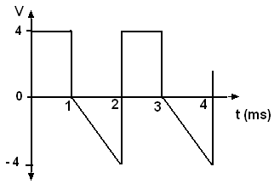  - A voltage of 200 53.8º is applied across two parallel impedance (12 + j16) Ω and (10 – j20) Ω. Determine the apparent, reactive, kW and power factor of the whole circuit. Also, draw the phasor diagram. | 7  8
 | - Explain with a neat diagram the two wattmeter method for the measurement of three phase power.  - A balanced 3 phase Delta connected load takes 10 KW at a p. f. of 0.8 (lagging) when connected to an 840 V, 3Ø, 3 wire supply. Find the per-phase load resistance and reactance value of each impedance. | 7  8
 | - How open circuit test on a single-phase transformer is performed?  - A 30KVA 2400/120 V, 50Hz transformer has HV winding resistance of 0.1Ω and a leakage reactance of 0.22Ω. The LV winding resistance is 0.035Ω and the leakage reactance is 0.012Ω. Find the equivalent winding resistance, reactance and impedance referred to HV and LV. | 7  8
 | - An iron ring of cross-sectional area 3 cm² and mean diameter of 12 cm has an air gap 2 mm wide. Calculate the AT necessary to produce a flux of 3.3 × 10⁻⁴ Weber in the gap. The iron has the following properties:  B (Wb/m²) : 0.9 1.0 1.1 1.2  H (AT/m) : 1270 1510 1830 2310  - Explain the operating principle of DC motor and generator. Write about the factors to be considered while selecting a motor? | 8  7
 | Write short notes on (Any Two):  - Requirements of basic instruments  - Voltage regulation of transforms  - Analogy between magnetic and electric circuit | 2×5

